Use case: Create account
Brief Description: This use case allows the user to create an account.

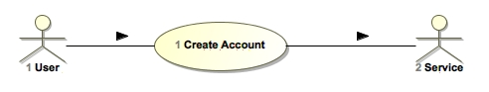

Figure 1: Use-Case Diagram

Basic Flow:
This use case starts when the users access the system feature that enables him/her to create an account by entering personal information that will be stored in the User’s account.

{Fill out Form}
- User enters required information values
- User press submit button.

{Validate Information}
- The system validates the information entered.

{Store data}
- The information is stored on user’s account.

{Confirm Account Creates}
- The system notifies the User that the account has been created.

Alternative Flows:

Handle Invalid Data Input
At {Validate Information} if system detects invalid data then:
- System prompts message to user to fix incorrect data or missing required data.
- System highlights the data that need to be fixed.
- User enters the missing data or corrects the data.
- The use case resumes basic flow at {Validate Information}.

Post-Conditions:
Confirmation is sent to user email informing success of account creation.

NEXT USER CASES TO CREATE

- Log in
- Log out
- Create repair request
- View repair requests
- Resolve repair requests

